Scanning Electron Microscopy and Energy Dispersive Spectroscopy of Glass Samples in Forensic Science
DOCUMENT TYPE:  GUIDELINE | REF. CODE:  EPG-GUIDELINE-04 | ISSUE NO:  xx | ISSUE DATE:  xx.xx.xxxx

GENERAL REMARK
This guideline assumes prior knowledge in the forensic discipline. It is based on consensus among the relevant forensic experts and reflects the accepted practices at the time of writing. The requirements of the judicial systems are addressed in general terms only.

Content Page

1 AIMS 3
2 SCOPE 3
3 DEFINITIONS AND TERMS 3
4 INTRODUCTION 3
5 METHODOLOGY 3
5.1 Electrons for imaging 3
5.2 X-Rays 4
5.3 Possibilities and Limitation 4
6 SAMPLE PREPARATION 4
6.1 Cleaning 4
6.2 Grinding/Polishing and Embedding 4
6.3 Coating and Fixation 4
7 Elemental Analysis 5
7.1 Calibration 5
7.2 Qualitative Analysis 5
7.2.1 Settings 5
7.2.2 Spectrum Acquisition 6
7.2.3 Identification Procedure 6
7.2.4 Escape and Coincidence Peaks 7
7.3 Specific Problems 7
7.3.1 Absorption effects on rough or irregular surfaces 7
7.3.2 Alkali Element Migration 7
7.3.3 Low vacuum skirt effect 8
7.4 Comparative glass analysis 8
8 References 8
9 AMENDMENTS AGAINST PREVIOUS VERSION 9

AIMS
This document describes a recommended procedure for preparation and analysis of glass samples by means of a scanning electron microscopy (SEM) with energy dispersive X-ray spectroscopy (EDS) in the context of forensic science.

SCOPE
This document covers Scanning Electron Microscopy and Energy Dispersive Spectroscopy of Glass Samples in Forensic Science. By application of the procedure as described qualitative and semi-quantitative analysis of the major and minor elements as well as some trace elements in glass can be obtained. The described procedure can be used for comparative glass analysis case work as well as a preliminary classification of unknown glass samples.

DEFINITIONS AND TERMS
See main document Best Practice Manual For The Forensic Identification and Comparison of Glass.

INTRODUCTION
The scanning electron microscope (SEM) is widely used as an analytical tool in forensic laboratories and is often available as it is used in other fields like gunshot residue (GSR) detection. The main advantage of this method is that a variety of information may be gathered with relatively a small amount of material present (sub millimetre). The sample’s elemental composition can be characterised by energy dispersive X-ray spectroscopy (EDS). This is a rapid and non-destructive technique that allows the subsequent examination of the same piece of evidence. The combination of SEM/EDS together with refractive index measurements provides improved discrimination in the comparison of glasses rather than rely upon one method. SEM/EDS is recommended when other methods of elemental analysis such as µXRF or LA-ICP-MS are not available or cannot be used due to sample size limitations.
This guideline aims to give a basic understanding and a first approach on SEM/EDS for glass evidence. We will introduce a concept so every laboratory with access to an SEM/EDS system will be able to produce comparable as well as reliable results on glass evidence.

METHODOLOGY
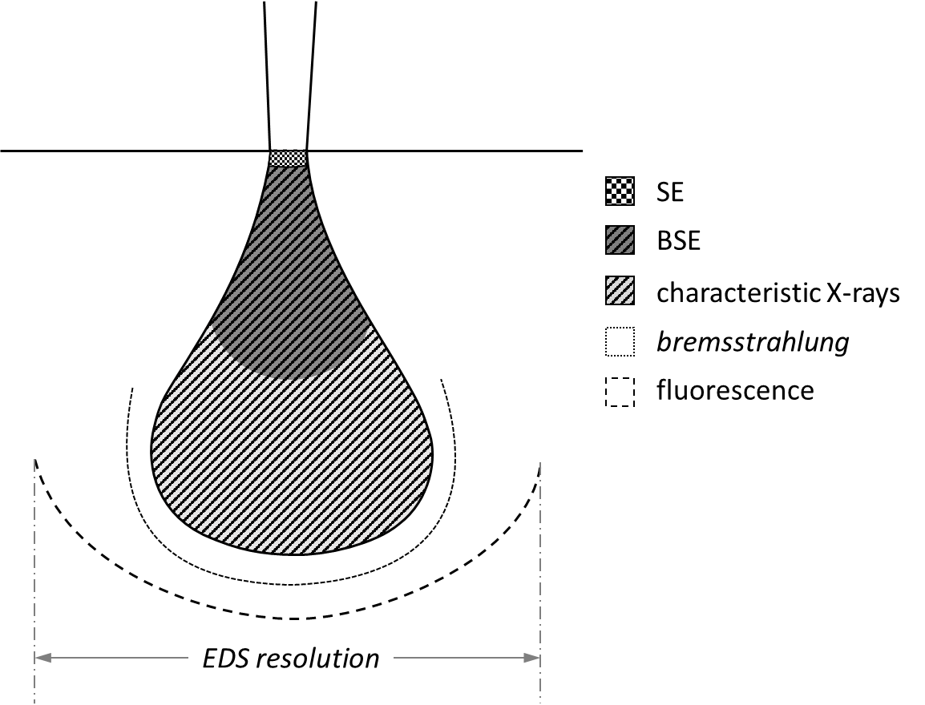
SEM/EDS analysis is based on the interaction of an accelerated and focused electron beam with solid matter. Figure 1 shows the schematic of an interaction volume. From this volume multiple detectable signals arise in form of electrons and x-rays.
Figure 1: interaction volume of an incident electron beam in dense matter

Electrons for imaging
Secondary electrons (SE) are electrons from the specimen ejected by the incident beam. These are of low energy (<50 eV) and carry topographic information and are generated in the topmost surface layer of only a few nm of the specimen (cf. Figure 1). Topographical contrast may be of interest to select an appropriate spot for an EDS measurement on irregular shaped samples/glass pieces to avoid geometrical absorption effects of surface features (cf. section 7.3.1).
High energy backscattered electrons (BSE) are formed by inelastic scattering events within the interaction volume of the primary beam and escape from a greater depth in the sample than SE electrons. These are laterally more dispersed (cf. Figure 1) than the SE and the BSE intensity increases with the (average) atomic number Z of the specimen and thus carries chemical or compositional information. By BSE imaging contaminations or inhomogeneity of the sample can be detected.

X-Rays
Detectable characteristic X-rays arise from a depth and lateral dispersion even greater than the BSE signal (cf. Figure 1) which in some circumstances can make a point analysis of very small features unreliable.
Besides in addition to the characteristic X-rays, a broadly distributed continuous background is generated (bremsstrahlung continuum) due to inelastic scattering events of the primary electrons with atomic nuclei of the sample. The intensity of bremsstrahlung is proportional to the mean atomic number Z of the sample as well as the accelerating voltage. A high level of background can prevent the detection of trace or even minor constituents. This effect can be reduced by measuring samples under different varying conditions (cf. section 7.2.1).
Besides the two main sources of possible interaction of the generated X-rays with the sample can lead to secondary fluorescence. Elements with lower X-ray energies can be excited by absorbing high-energy X-rays from nearby atoms. This leads to an even broader area of X-ray generation and a coarse resolution for EDS compared to electron imaging. Depending on acceleration voltage and the mean atomic number, the total interaction depth and broadness can extend up to several µm, which must be kept in mind, when analysing small areas surrounded by different material. When secondary fluorescence arises from matter outside the sample (e. g. the SEM’s chamber interior) this can lead to false positive element identification.

Possibilities and Limitation
Qualitative and semi-quantitative SEM/EDS analysis is often used for the comparison of glass fragments. Whilst not specific to provide strong evidence for a common origin, qualitatively similar spectra can support this theory, whereas significantly different spectra provide evidence of a different origin.
SEM/EDX is sensitive for elements with an atomic number Z≥5 (Boron), although this depends on the X-Ray detector. If the detector has a beryllium window, EDS lines of elements with Z≤11 (Na) cannot be detected.
It is possible to examine glass fragments with a size smaller than 10 µm, that are too small for most other analytical methods. However, due to its small beam diameter and surface sensitivity the method is prone to sample contamination as well as material inhomogeneity. As described in section 5.2 the spatial resolution of EDS is in the order of several 100 nm up to a few µm (depending on the accelerating voltage) compared to a nm lateral resolution for SEM imaging.

SAMPLE PREPARATION

Cleaning
Any foreign material present on the glass fragments should be removed for further analysis, if relevant. Dirt, salt or any other non-significant material can be removed by scraping with a scalpel or washing with a soaked piece of tissue or a dipped cotton swab with water, ethanol or any other suitable solvent. If necessary, an ultrasonic bath can be used.

Grinding/Polishing and Embedding
Glass samples may be grinded/polished in order to achieve flat surfaces. Flat surfaces improve the accuracy and precision of SEM/EDS analyses and are prerequisite to quantitative analysis. To enable grinding and polishing the surfaces of small glass fragments, they can be embedded in a polymer matrix, such as a methacrylate resin, commercially available light curing or chemically curing resins may be used.

Coating and Fixation
Most glass samples are not electrically conducting. On a high vacuum SEM (p<10⁻⁵ mbar) conductive coating of the surface and a thorough contact to (electrical) ground of the instrument is necessary. The recommended coating material is carbon with a thickness of approx. 5-10 nm. Metal coatings, such as gold, are less favourable due to its possibly interfering X-ray lines and absorption effects. For the coating process follow the operating instructions of your coating equipment’s manufacturer.
When using embedded samples for analysis ensure the (conductive) surfaces have electrical contact to the instrument’s electrical ground (i.e. the stage). This can be done by connecting the sample holder and surface with conductive tape, conductive silver or carbon paste or by coating the sidewalls of a nonconductive embedding resin. Suitable samples can be fixed on a conductive carbon pad without embedding.
When using a low vacuum SEM, the coating of samples is not required. For possible limitations and drawbacks see section 7.3.3. While it is an absolute necessity to use a conductive stub and pad for fixation in high vacuum SEM, their use is also recommended and good practise for the low vacuum applications.

Elemental Analysis

Calibration
The EDS system’s functionality should be checked on a regular basis (preferably weekly) or when there are concerns about the correct performance of the system by measuring a well characterized sample. The generated spectra should be inspected critically regarding the peak shape and peak energy to reveal potential problems.
The EDS system must be energy calibrated on a regular basis (preferably monthly) or when there are concerns about the correct performance of the system. Modern spectrometer software allows an automatic two-point energy calibration using a standard material of known composition, preferably a transition metal such as copper providing high and low energy characteristic energies (E(Cu-Lα) = 0.928 keV and E(Cu-Kα) = 8.040 keV).
Alternatively, a composite material (e. g. Cu/Mn) can be used. For calibration follow your EDS software’s application notes. The EDS detector and counting electronics are sensitive to temperature changes, therefore the room temperature of the laboratory should be kept within a minimum fluctuation.
At least the calibrated FWHM must be documented but it is strongly recommended to keep a documentation of all calibration spectra as a quality assurance measure to detect and backtrack malfunctions.

Qualitative Analysis

Settings
The following instrumental settings are recommended for a standard glass analysis by SEM/EDS:
- Excitation energy/voltage ≥ 20 kV (at least one detectable line set from B to Pu)
- For better detection of light elements (such as B) or heavy metals (such as Pb) a variation of the accelerating voltage to 5 kV or 30 kV can be beneficial. As stated in section 5.2 the bremsstrahlung background diminishes when reducing the accelerating voltage. This can be useful to detected trace elements if the reduced voltage is at least 2x greater than the X-ray line energy of a possible trace element.
- channel resolution ≤ 10 eV/channel
- Process time: the process time should be chosen according to the best achievable peak resolution (preferably ≤ 135 eV for the FWHM of the Mn Kα peak) with regard to the points v.) and vi.). Shorter process times allow higher beam currents and thus maximise the throughput while longer process times enhance the resolution (FWHM).
The use of an “adaptive process time” (or similar) is strongly discouraged.
- Dead time: ≤ 30 % for selected process time, preferably < 20 % to minimise coincidence peaks with respect to the acquisition time.
- Acquisition time: The combination of selected dead time, input count rate (beam current) and acquisition time should be set so minimum of 250,000 (preferably 1,000,000) counts are stored in the spectral range.

Example: An input count rate (ICR) of 3,250 cps with a dead time of 30 % results in an output count rate (OCR) of 2,500 cps.‡ That yields a total live time of 100 s for a statistically accurate analysis with a total of 250,000 counts.
‡ Modern spectrometers provide a dead time correction, so this is just to clarify

With modern solid state detectors (SDD) detectors a much higher output count rates is usually possible when compared to Si(Li) technology.
- The EDS measurement should be performed at (or as close as possible to) the SEM’s analytical working distance (manufacturer-specific, please consult your microscope’s specifications)
- If the sample-detector-distance is variable (i.e. the detector is movable into the chamber) the detector has to be positioned as close to the sample as possible and without interference with the other chamber equipment to ensure the best possible count rate. For reproducible measurements the detector has to be fixed at this position for precise reproducibility.

Spectrum Acquisition
For every (sub)sample at least three measurements under the same conditions determined in 7.2.1 should be performed. The size of the measured areas must be chosen with respect to the alkaline migration (cf. 7.3.2), possible skirting (cf. 7.3.3), the material’s homogeneity and the comparability of the measurements as large as reasonably possible and consistent for all measurements. Spot measurements can be sufficient but are prone to contamination and absorption effects.
After identification by the procedure described in 7.2.3 their elemental composition must match. If this is not the case the sample has to be checked for inhomogeneity and surface contamination and the specific problems shown in 7.3 have to be considered. The full analysis should be repeated with these factors in mind.

Identification Procedure
Modern EDS analysis software allows an automatic peak identification. If the automatic identification is used, a critical check has to be performed as there is the possibility of misidentification due to severe peak-overlap and energy similarity of elemental peaks (e. g. Al/Br, Ba/Ti, Mo/S, Pb/S besides others [4]) These algorithms are far from perfect and so the spectrum must be inspected critically performing the following procedure:
- The acquired spectrum has to be checked for statistically significant peaks. A peak is
considered significant if its netto intensity I_{netto} greater the 3 times the standard deviation of the background intensity in the framing background regions.
- The peak with the highest intensity above E > 3 keV is assigned to a fitting element. To positively identify an element all line family members (e.g. Kα and Kβ) must be present in the correct intensity ratios. For strongly overlapping peaks of different elements it may not be possible to determine the intensity or even the presence of a peak directly and the presence of an additional element may only be hinted by another peak’s deviation from a symmetric gaussian shape. This can be approached by a mathematical peak deconvolution offered by most modern software. The sum of the individual deconvoluted peaks should match the measured intensity as close as possible. With decreasing absolute intensity some line family members may not be distinguishable from the background signal and thus the element identification becomes less certain.
- The low energy lines (families) of the identified element in (2) are assigned. Potential escape and coincidence peaks of the identified element are determined and assigned (cf. 7.2.4). In the low energy regime sublines may not be fully resolved (< 3 keV).
- Step (2) and (3) are repeated with the next highest intensity peak until all peaks in the spectrum are identified as an element peak, coincidence or escape peak. For better identification longer live times or the use of a wavelength dispersive spectrometer (WDX) can be applied if available (not part of this guideline).

If the analysis program offers a peak deconvolution option the total convoluted spectrum should match the measured spectrum without severe differences. If this is not the case check for coincidence peaks of two identified elements or mis- and unidentified elements (cf. 7.2.4).

Escape and Coincidence Peaks
X-ray photons interaction with the detector material (mostly silicon) leads to escape peaks with an energy difference of 1.740 keV from its parent peak. This can lead to a potential element misidentification when the coincidence peak has the same energy as another element line.
Measuring at high dead-times, two X-ray photons arriving at the detector simultaneously cannot be resolved by the detection electronics and so creates an artificial peak which is the summed energy of the two parent photons. Like escape peaks this may lead to a wrong element identification.

The intensity of coincidence (and to a smaller extent escape) peaks is dependent on the dead-time respectively the total input count rate. Therefore, it is possible to suppress (but not avoid) coincidence peaks by measuring at deadtimes < 15 %. A dead-time dependent intensity measurement can discriminate coincidence peaks from element peaks.

Modern EDS software packages are able to label and even correct measured spectra for escape and coincidence peaks. Please consult your instruments handbook for these processes. These algorithms are however far from perfect, so the existence of escape and coincidence peaks is to be expected and considered in every measurement.

Potential Pitfalls

Absorption effects on rough or irregular surfaces
Measuring rough/irregular or inclined surfaces, pointing away from the EDS detector can result in a change to the EDS spectra. Due to the x-ray absorption of matter in the low energy regime, the intensity of the low energy x-ray lines might be reduced or the lines can even be supressed. This effect can be avoided by choosing the analysis spot correctly, so that the measured surface is not tilted away from the detector or high surface features in the neighbourhood prevent the generated x-rays from reaching the detector. To make sure absorption does not alter the element identification, several spectra should be measured across the sample and compared so as to avoid missing any element due to (surface) absorption. To estimate inclination/tilt of surfaces the SE signal (cf. section 5.1) of the SEM is most useful in minimising surface effects.

Alkali Element Migration
Although glass is usually not beam-sensitive, the light alkali metals (Na, K) can migrate from the glass surface layer under certain conditions: when a local charge is induced by the electron beam sodium and potassium ions might be repelled even though a conducting layer for sample discharging has been applied. This effect is the more severe with a higher the beam current and a longer the scanning time (a higher volumetric dose), also the smaller the scanned area the more pronounced for sodium than for potassium. It must be noted that for high dose measurements of small glass fragments this leads to significantly underestimated alkali metal concentrations even as far as a false exclusion of the element.

Low vacuum skirt effect
Operating a SEM/EDS system under low vacuum conditions (0.1-10 mbar) skirting must be considered: Inelastic scattering of the electrons within the chamber gas leads to excitation of said gas resulting in characteristic X-rays, bremsstrahlung background (as described in section 5.2) as well as beam broadening. The effect of beam broadening can be estimated analytically.[5] Performing EDS in low vacuum atmosphere the dimensions of the spot to analyse must match the beam diameter broadened by skirting and should be performed at the lowest possible pressure.

Comparative glass analysis
A comparative analysis of two glass fragments can be made by inspecting the EDS spectra acquired for each sample. These are compared and elements identified using line position and line intensity of each element. A comparison requires similar measurement conditions of the two samples, i.e. in accelerating voltage, water pressure (if applicable), measurement geometry, live/dead-time as well as sample preparation and coating thickness and material. When comparing rough/unpolished samples it is important to use spectra from positions that are unaffected by surface absorption anomalies. The spectra should be measured from regions with a similar tilt/inclination (cf. 7.3.1). Surface contamination can compromise such a comparison, in addition to the possible presence of a functional glass layer.
If there are differences between the samples in the comparative material in line position or intensity that cannot be explained by statistical counting error, or by surface absorption effects or the sample’s inhomogeneity, the EDS suggests a difference in elemental composition.

References
[1] | J. I. Goldstein et al. Scanning Electron Microscopy and X-Ray Microanalysis, 4th ed., Springer, London/New York 2018
[2] | S. J. B. Reed Electron Microprobe Analysis and Scanning Electron Microscopy in Geology, 2nd rev. ed., Oxford University Press, Oxford 2005
[3] | R. Jenkins et al. IUPAC—nomenclature system for x‐ray spectroscopy, X‐Ray Spectrom. 1991 (20) 149-155.
[4] | D. Newbury Mistakes encountered during automatic peak identification of minor and trace constituents in electron-excited energy dispersive X-ray microanalysis. Scanning. 2009 (31) 91-101.
[5] | G. Danilatos Environmental Scanning Electron Microscopy, Microchimica Acta 1994 (114) 143-155.

AMENDMENTS AGAINST PREVIOUS VERSION
Not applicable.

###

Although it can only be considered non-destructive if the glass is not embedded and polished. The grinding and polishing step leads to a physical degradation and may compromise further examinations (cf. section 7.3.).
May also be called: time constant, amplification time, peaking time
Environmental Scanning Electron Microscopy (ESEM) is performed at even higher chamber pressure (up to 25 mbar). Due to severe gas absorption and skirting problems microanalysis in ESEM must not be performed for forensic glass samples.

