29th ENFSI EWG Firearms / GSR Meeting
4th – 6th October 2023 in Brussels, Belgium
Official Invitation

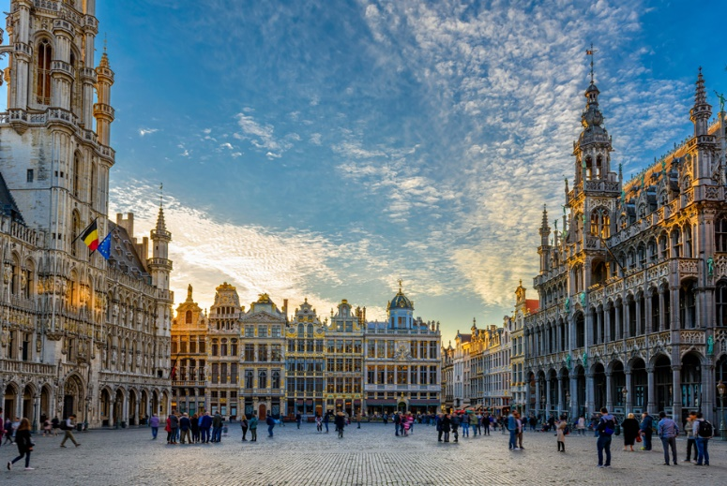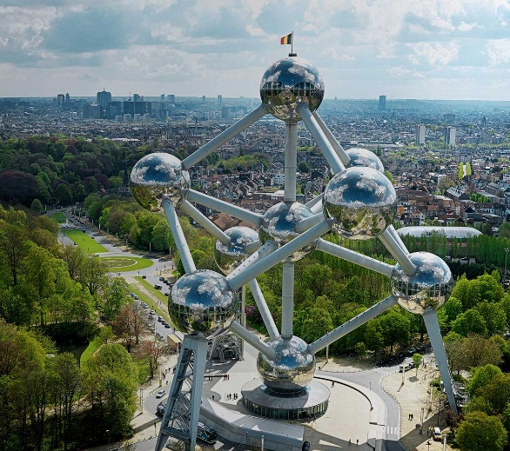
© Shutterstock © Atomium asbl

Dear colleagues,

On behalf of the FA /GSR steering committee and the NICC Brussels we have the pleasure to invite you to the 29th ENFSI EWG Firearms / GSR Meeting that will take place from October 4th to 6th 2023 in Brussels. The meeting starts on Wednesday morning (October 4th) and will finish at lunch time on Friday (October 6th) and includes at least one workshop for Firearms and at least one for GSR (topics to be determined).
Besides the official program we have paid a lot of attention to give participants the opportunity to meet each other and discuss with exhibitors of scientific equipment during several coffee breaks and lunches, but also by organising social activities on Tuesday (Get Together) and Thursday (Gala Dinner). We hope that you will enjoy your stay in Brussels as well as meeting the other participants.

If you have any questions do not hesitate to contact us using the following e-mail:
NICC-MAT@just.fgov.be

Looking forward to seeing you all in Brussels!

The firearms and GSR team @ NICC
Meeting organiser (person of contact Sébastien CHARLES)

Kal CHANA
FA / GSR chairperson
Conference venue
The conference will take place at the ‘Pacheco Center’. This is located in the city centre of Brussels nearby the Botanical Garden and the Financial Tower. This is easily accessible by foot from Brussels Central Station (NL: Brussel Centraal Station / FR: Bruxelles Gare Centrale) (10-15min walk) or by public transport from this train station getting off at ‘Botanique/Kruidtuin’ stop when using Metro/Tramway.
The ‘Pacheco Center’ entrance is located at the Boulevard Pachéco 13 in 1000 Brussels, Belgium at the side of the Financial Tower where you will find a lobby with a registration desk and the main meeting room. The exhibitor area will be located at the back of the lobby.

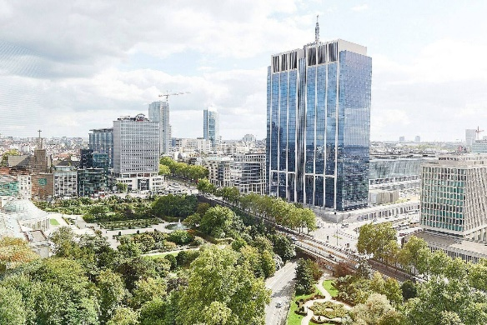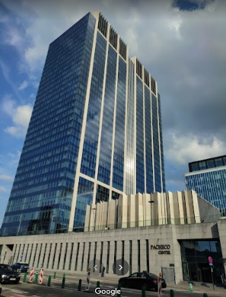
Finance Tower
Pacheco Center

Registration
The registration is available online using the following link:
https://docs.google.com/forms/d/e/1FAIpQLSfiX_mD9RAl4kixzITNG6EtDtSgOpqOv137Fxcgk36tTwpg9g/viewform?usp=sf_link
For security reasons, this link may not be accessible via a professional network. However, it should at least be accessible using a smartphone and the mobile network. If you encounter any difficulties in registering, please contact the organisers directly (NICC-MAT@just.fgov.be).
A welcome pack will be distributed in the lobby of the Motel One on Tuesday evening, before the ‘Get Together’ event. For late travellers it will also be distributed in the lobby of the conference room on Wednesday morning, before the opening of the meeting.

Who should attend?
Colleagues from the FA / GSR within ENFSI (Members, Associate Members and invited guests) are eligible to attend this meeting. FA / GSR membership is open to ENFSI forensic institutes that are active in the field of firearms and GSR examination. Associate membership is available for non-ENFSI and non-European institutes that are active in these fields of forensic examination.
Non-members of FA / GSR may attend the 2023 meeting as guests with the permission of the FA : GSR chair. Those wishing to attend as guests should contact us to declare their interest (NICC-MAT@just.fgov.be).

Call for Presentations
Please offer your scientific and case related contributions when registering online, this (for organisational reasons) during the early bird period. Every single contribution (oral presentation and/or poster) is more than welcome. We really encourage you to take an active role in the annual meeting. Bear in mind that the main purpose of the meeting is the exchange of ideas. That’s the way we can learn from one another.
If necessary, the Steering Committee will make a selection from the submissions. The final programme will be established in July.
Please notice that the poster session will consist of a virtual session (no physical poster is needed).

Workshops
The workshops are part of the meeting and no additional registration/fee is needed. More information will follow.

Annual Meeting Registration Fee
Participants
Meeting fee for Members: | 320 € (early bird)  370 € after early bird
Meeting fee for Associate Members and Guests: | 384 € (early bird)  434 € after early bird
Accompanying person fee: | 200 €

The participant’s fee includes:
- Rental of the conference and workshop rooms
- Conference material
- Welcome reception on Tuesday 3rd of October
- Lunches – coffee breaks
- Gala dinner on Thursday 5th of October

The accompanying’s person fee includes:
- Welcome reception
- Gala dinner

Early bird registration is 15th of June

Final deadline for registration is 22nd of September

Payment Details
Please transfer the total amount to the account indicated on the invoice you will receive after registration. The payment should be received as soon as possible but not later than 30th of June (early bird) or 29th of September (after early bird).
Refund Policy
In case of cancellation by the participant:
- 100% refund until 31st of August
- 50% refund until 30th of September
- 0% refund afterwards, but option to change the name of participant offered

Get Together Event
You are invited to join the welcome reception at Motel One on Tuesday evening (October 3rd).

Contact
If you have a problem in Brussels during the meeting you can get in touch with the NICC organizing staff using the following number : +32 474 27 14 26

Hotels
There are many hotels in Brussels that can be easily found on usual booking platforms.
The organisers have made a special arrangement with three hotels; a sufficient number of rooms have been reserved, but only guaranteed until 03/08/2023. We recommend to make reservations quickly, as October is a busy month (trade fair) in Brussels. Below is a summary table:
 | Location | Rate (3 nights single occupancy, breakfast and city taxes included) | Registration deadline with guaranteed rate | Registration | Cancellation policy
Motel One Brussels | Rue Royale 120  1000 Brussels  (10min walk) | € 417.42 | 21/08/23 | Reservation form | Free of charge before 03/10/23
Ibis Brussels City Centre | Rue Joseph Plateau 2  1000 Brussels  (20min walk) | € 551.72 | 18/08/23 | Reservation form | Free of charge before 30/09/23
Thon Hotel Brussels City Centre | Avenue du Boulevard 17  1210 Brussels  (10min walk) | € 522.72 | 05/09/23 | https://www.thonhotels.com/event/annual-meeting-enfsi-firearmsgsr-2023-brussels-belgium/ | Free of charge before 29/09/23

Please book the discounted room rate directly with the hotel using the forms attached to the email containing this invitation (Motel One and Ibis) or on internet (Thon).
The discounted rooms will be assigned on a basis of ‘first come, first serve’. The organising committee cannot be held responsible for any problems in the hotel reservation process.

